WELLS AP KINSLEY


Emergency Evacuation Policy and Procedure

Date Approved: DEC 2025
Review date: DEC 2026

To meet the requirements of the Secondary Education the Provision must consider the potential risk of a fire in the Provision and take the following steps:
- Contact the local fire safety officer to have a Provision safety check, this was completed on the 15.04.2023 by Megan Walker Fire Safety Inspector
- Make sure that evacuation routes have been identified and are clear and accessible at all times. (checked on a daily basis)
- Ensure that Fire Wardens and Marshals are aware of what to do in order to reduce or prevent potential risks.
- Produce a written diagram detailing the escape route we will take with children in case of fire.
- Ensure we have the appropriate smoke alarms on each floor and ensure they are located in the most appropriate place, considering doors that may be closed and location of the Kitchen.
- Keep a record of the date the smoke alarms are checked and any action required.
- Regularly practice a fire evacuation with all children and Staff.
- These will be carried out Half Termly
- Making sure we keep a log of:
  - The date of the drill
  - Names of children in attendance
  - Time taken to evacuate
  - Issues which slowed down the evacuation
  - Action to be taken
  - Date action completed.

- The provision procedure in an event of an emergency is as follows:
  - In the event of a fire, we will calmly gather the children together and we will make our exit via the identified fire exit route.
  - We will ask children to listen very carefully to our instructions.
  - We will ensure the younger children are carried to safety.
  - The children will not collect their belongings.
  - When we are safely out of the building, we will gather at the designated Fire Assembly point in the Car Park

  - We will check the register and carry out a head count of the children in our care.
  - We will ring 999 using a mobile phone.
  - We will ensure that a mobile phone is fully charged at all times, and has telephone contact details of all the parents and/or carers of the children in our care.
  - Parents and/or carers will be informed as soon as possible.
  - We will not re-enter the building for any reason until advised by the Fire Service that it is safe to do so.
The following information is unique to my premises:
Fire Extinguishers
Location | Extinguisher Type
Kitchen Side Lobby near Main Hall Door | Water Mist
Kitchen by the Door | Water Mist
Kitchen Wall near Sink | Fire Blanket
Office Side Lobby near Double Fire Door | Water Mist

Extinguishers are checked annually by:
Sandal Security Limited

Fire Warning System is a Category L2
Checked every Six months by:
Sandal Security Limited

Emergency Lighting System is a mixture of maintained and non-maintained units.
Checked every Six months by:
Sandal Security Limited

Emergency Escape Routes are indicated by Exit signs.

Records of Fire Warning System Tests are maintained by Sandal Security Limited

Records of Emergency Lighting Systems Tests are maintained by Sandal Security Limited.

Records of Evacuation Drills are Maintained by David Hill

Records of Staff Instruction and Training are maintained by David Hill

Discovery of a Fire:
If anyone discovers a fire they must:
- Immediately raise the alarm
- Ring 999 and ask for Fire Service
- Evacuate the Provision as quickly as practicable
- Attack the Fire with the relative Fire Extinguisher
- If unable to fight fire evacuate to the designated assembly point.
- Clear the area for Emergency Services

Identified escape routes: See Diagram

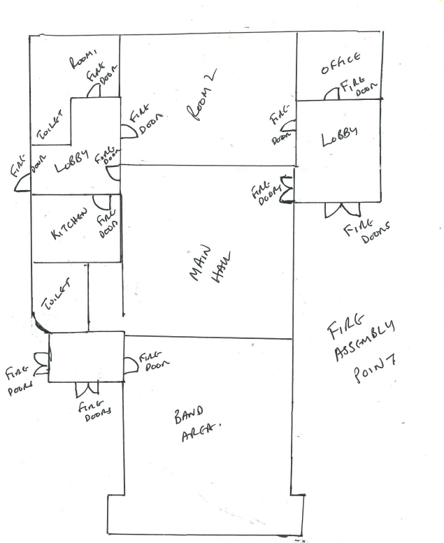

Keys would be located: In the Office and by DHi

Assembly point: Designated Fire Assembly Point in Car Park

Other relevant information:

Name of Provision The Wells Academy Yorkshire Ltd.

Health and Safety Officer David Hill …………………………………………………………………..

Date: 17th April 2023…………………………………………………………………………….

